CHAPTER 7: Elements, compounds and mixtures
Worksheet 7.3

Metals and non-metals
Student: Class:

Classifying elements
1. Complete the following diagram by inserting words and phrases from each section of the lists below:
Groups: metals, non-metals
Properties: dull, lustrous, good heat conductor, poor heat conductor, poor electricity conductor, good electricity conductor, brittle, malleable, high melting point, low melting point
Examples: iodine, zinc, fluorine, copper, phosphorus, silver
Symbols: F Ag Zn P I Cu
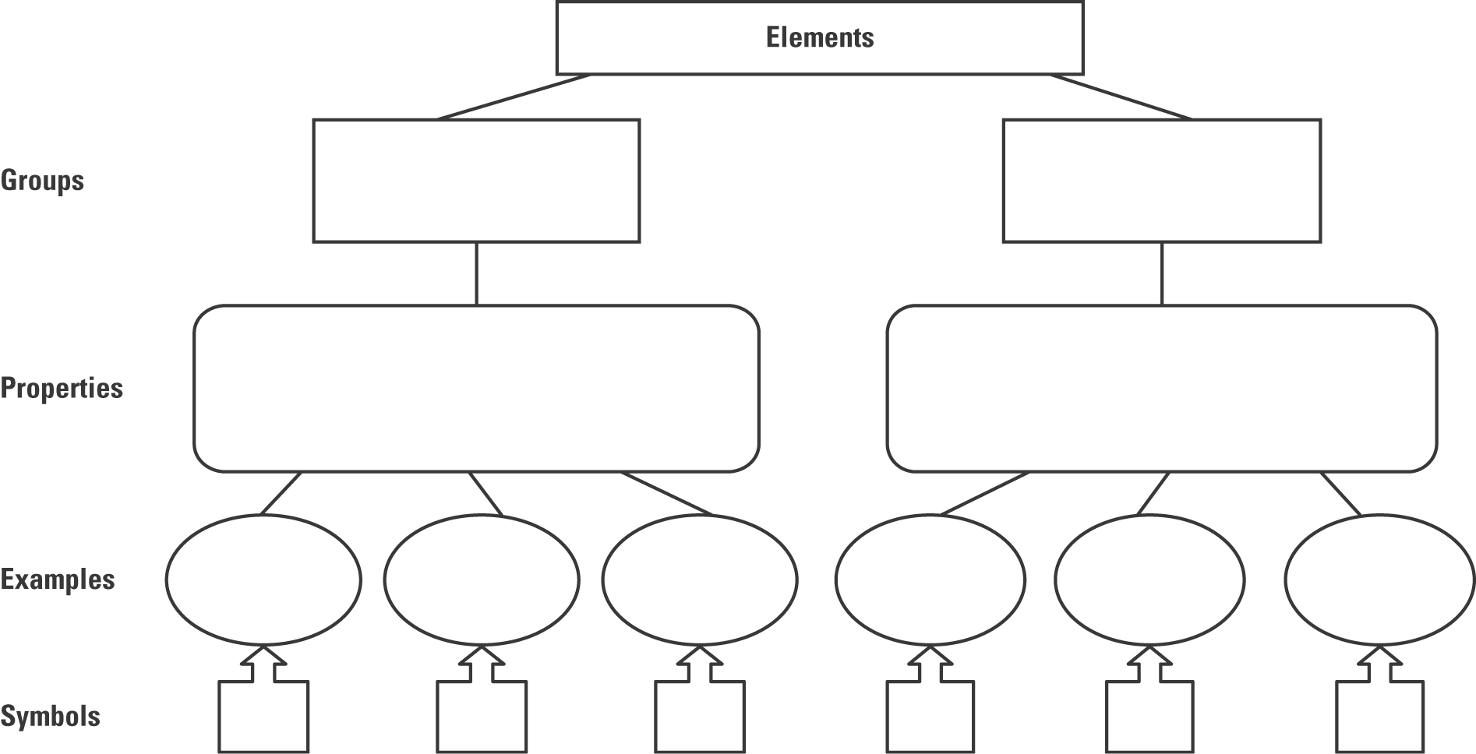

Metalloids
2. Not all elements readily fit in the metal or non-metal groupings. These elements are called metalloids. There is some disagreement about the number of metalloids. The metalloids are: boron, silicon, germanium, arsenic, antimony, tellurium and astatine (polonium is classified as a metal rather than a metalloid by many authorities). Examine the table below and classify W, X and Y as metals, metalloids or non-metals.
W: | X: | Y:

Property | W | X | Y
Lustre | Moderately high | Low | High
Electrical conductivity | Low | Nil | High
Density | Medium | Low | High
Melting point | Very high | Low | High

